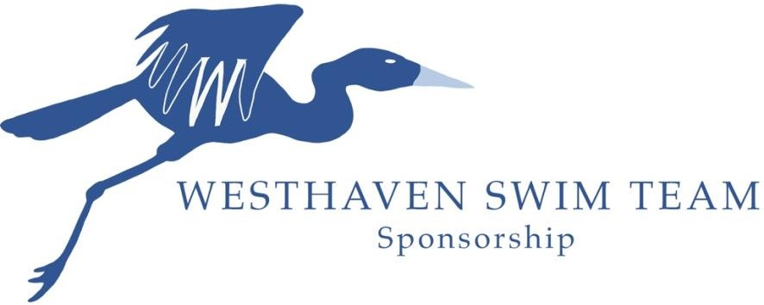

Thank you to all of our inaugural year Swim Team Sponsors. Your support helped us launch Westhaven’s first summer swim team, providing a fun and healthy activity for kids ages 4-18 in our neighborhood. The Westhaven Swim Team is a non-profit organization (501c approved) dedicated to providing the finest summer swim team program available. We will compete against other teams in the Williamson County Swim League. Your sponsorship money will be used for coaching fees, equipment, trophies, T-shirts for the swimmers, and the end of year party. For more information, please contact westhavenswimteam@gmail.com.

This year we are unveiling a unique opportunity to spotlight your company in our weekly newsletter. At our Platinum level, we would add a paragraph that you write (250 words) about your company. If you would like to have this opportunity, please submit your 250 words with your application.

We are allowing the team to grow to 250 swimmers this year, and that roughly is about 200 individual Westhaven families!!

Sponsorship tiers are shown below – circle one and make check payable to Westhaven Swim Team.

Silver $250 | Gold $500 | Platinum $1000+
Logo on Website  Logo on Season Banner  Logo on Team Shirt  Logo on Weekly Newsletter | Logo on Website  Logo on Season Banner  Logo on Team Shirt  Logo on Weekly Newsletter  Thank You at one Home Meet  Shout out on Instagram | Logo on Website  Logo on Season Banner  Logo on Team Shirt  Logo on Weekly Newsletter  Thank You at one Home Meet  Shout out on Instagram  Lane Sponsorship  Spotlight in the Weekly Newsletter

Sponsor Name: Address: Email: Phone: Website:

